Operation instruction of

Business SJ6200 Century Star Ink Jet Printer

Beijing Dongfang Business Electronic Technology Co. Ltd.

Thank you for selecting and purchasing business SJ5100 Century Star Ink Jet Printer, before operation please carefully read this manual to derive the best operation effect.

Precaution: The ink, cleaning agent and thinner of this machine are dedicated and are specially made by our company for you, and it is not allowed to use products provided by other units, so as to avoid the damage to machine. The ink and thinner are both flammable and shall be stored far away from fire source. In case of sudden power cut, the power supply of machine shall be timely cut off and the jet head be washed and cleaned up.
When high voltage pole plate is washed, the high voltage must be closed down, otherwise it shall incur high voltage ignition and be very dangerous. The photoelectric switch shall not be washed by thinner or washing agent, so as to avoid damage thereof.

Beijing Dongfang Business Electronic Technology Co. Ltd.
Address: Room 204, building 20, No. 43 Tiancun Road, Handian District, Beijing
Postal code:100143
Tel:010-68472805
Contents

1.Theory of ink jetting and printing 2
2. Property parameter of machine 2
2.1 Operation condition: 2
2. 2 Parameter of work property: 2
2. 3 Physical object indicator 2
3. Structure and theory of machine 2
3.1 Measurement and setup of ink viscosity: 2
3.2 Structure of machine: 2
4. Installation and debugging 2
4.1 Requirement of installation place: 2
4.2 Installation of each part 2
4.3 Debugging step 2
5 Operation program 2
5.1 Keyboard operation 2
5.2 Operation of machine 2
6. Maintenance and precautions 2
6.1 Maintenance of machine 2
6.1.1 Daily maintenance: 2
6.1.2 Maintenance for long term shutdown 2
6.2 Regulation of related parts 2
6.2.1 Regulation of broken point of ink line 2
6.2.2 Regulation of character height 2
6.2.3 Regulation of ink line position 2
6.3 Precautions of operation 2
7. General fault and elimination method 2

1. Theory of ink jetting and printing
Refer to Fig. 1-1. The pressured ink is jetted from the jet head and form ink line, under the effect of crystal oscillator it is broken to droplets. The ink droplet is charged when passing through charge electrode. The charge quantity is controlled by single chip microcomputer. The detection electrode is below the charge electrode, and can detect the situation of charge of ink droplet to control its charge. The charged ink droplet is deflected after passing through high voltage electrical field, and its deflection distance is controlled by single chip computer. If the object moves at the direction vertical to paper surface, some ink droplets can form lattice graphics on this surface.

2. Property parameter of machine

2.1 Operation condition:
Environmental temperature 5—40°C
Environmental humidity 10-90%RHb(no dew)
Power supply 220±10%VAC,50Hz, good earthing

2. 2 Parameter of work property:
Max. speed and character height of character jetting:
Format of character lattice Speed (character/second) line layout speed (m/second) Character height (mm)
8×8 lattice (single row) 480 0.96( character width 2.0mm) 1.8-10.0
12×12 lattice (single row) 360 0.96( character width 2.7mm) 1.8-10.0
16×8 lattice (double row) 210 0.21( character width 2.0mm) 1.8-12
8×8 lattice (double row) 158 0.21( character width 2.7mm) 1.8-12
16×12 lattice (single row) 45 0.22( character width 5.0mm) 3.0-10.0
16×16 lattice (single row) 28 0.22( character width 7.8mm) 3.0-12
Note: Above mentioned line layout speed is the value for the designated character width, when character width is decreased (increased), the line layout speed shall be accordingly decreased (increased).
Category of character
The jet head bottom is 2-15mm apart from surface of lettering object.

2. 3 Physical object indicator
The external appearance of ink jet printer see physical object.

3. Structure and theory of machine

3.1 Measurement and setup of ink viscosity:
The size of viscosity of ink directly impacts the goodness/badness of broken point. This machine adopts the following method to measure the viscosity of ink: Under certain ink pressure, measure the time of ink of volume from lower link position to upper ink position passing through flow limit valve (second), this time is the viscosity of ink. Each time the ink pump in the machine works, the viscosity value shall be refreshed by one time.
It needs to be emphasized that, each jetting cavity has a viscosity value scope, when ink viscosity value exceeds this scope, the jetting cavity cannot normally work, the ink viscosity is too high, and points appear on the ink line; when the ink viscosity is too low, the ink line cannot be broken. Thus the ink viscosity on the machine can only be set up as per designated viscosity without setup at one’s own discretion.

3.2 Structure of machine:
The front chamber of machine see physical object.
The rear chamber of machine see physical object.

4. Installation and debugging

4.1 Requirement of installation place:
The ground for laying the machine shall be hard and level. The front and rear direction of the machine shall be reserved by at least 1m space with good ventilation. The jet head and photoelectric switch shall be stably installed on the supports. The principal machine, jet head support and jet head guide pipe shall not be vibrated at all. In the circumference of principal machine and jet head it shall be noted by apparent wording of “fireproof and waterproof”. Since the ink and thinner are both flammable, in the circumference of principal machine (not more than 3m) it shall beat least placed by one CO2 extinguisher, and shall not be stocked by flammable material.

4.2 Installation of each part
Circuit:
The power supply plug of principal machine is inserted in the outlet of AC stabilized voltage power supply, AC voltage stabilized voltage power supply input plug is inserted in 220V power supply, and good earthing shall be ensured.
Jet head:
The jet head support is installed well, the jet head and photoelectric switch is stably installed on the support as per move direction of product.

4.3 Debugging step
After the new machine is installed without problem of visual inspection, the debugging can be done. The steps are below:
(1) The power supply of user is connected.
(2) Carry out parameter and information input and supply ink as per statement of chapter 5.
(3) Regulate the sine wave voltage value (100V-250V has been set during ex-factory), and the broken point as shown in Fig. 3-3 is obtained. Under the main menu, the panel phase indicator shall be Off.
(4) Enter printing status as mentioned in chapter 5, press the key of “high voltage connection” of panel and then it can be printed.

5 Operation program

5.1 Keyboard operation
After the principal machine is powered on, input the password 999, and it has following contents displayed on the screen:
l parameter setup 2 Character editing
Main menu
3 ink way operation 4 Start printing
5Status display 6 self edited lattice

(1) Parameter setup :
In the main menu press key 1, enter parameter setup sub-menu. This submenu is displayed as below:
********* Parameter setup sub-menu ********
1. Selection of printing control 2. Selection of lattice row/column
3. Multiple of character widening 4.Delay of printing
5. Product counting upper limit 6. Product counting lower limit
7. Setup of ink viscosity 8. Setup of reverse character and upside down character
9.Setup of printing speed A. Setup of row interval
B. Setup of quality of jetting and printing

REN main menu

Under the parameter setup sub-menu, press key 1-9 to respectively enter the related parameter setup page.

Selection of printing control
Sub-menu of printing control
Setup of current printing mode: Automatic printing
A: Automatic printing
T: Photoelectric control printing

REN parameter setup sub-menu

Press key A for automatic printing: Press key T, photoelectric switch control. The so called photoelectric switch control means that the printing is controlled by photoelectric switch, each time the computer accepts one photoelectric switch signal, the jet head shall print some information. The so called automatic printing means that, the printing is not controlled by photoelectric switch, under this status, the jet head shall be of continual printing without control of photoelectric switch.

Selection of lattice row/column :
1. 8 rows Selection of lattice row/column
2. 12 rows Setup of current lattice:8 rows 8 columns
3. 16 rows
4. 24 columns
5. 8 columns
6. 10 columns
7. 12 columns
8. 16 columns
9. 24 columns
REN parameter setup sub-menu

One character unit is composed of points of M rows and N columns (MxN). For example the character of 8×8 lattice is composed of points of 8 rows and 8 columns. Between the characters it must be reserved by clearance, in fact, 8×8 lattice character is composed of 7×5 lattice, generally the last column is blank (no point). The following are character jetting and printing form and the related situation of setup of lattice:

Character form Rows Columns
7×5 lattice (E.g., Arabic numerals, English alphabets or simple Chinese characters) single row 8 8
7×5 lattice (E.g., Arabic numerals, English alphabets or simple Chinese characters) double rows 16 8
7×5 lattice (E.g., Arabic numerals, English alphabets or simple Chinese characters) three rows 24 8
16×12 lattice Chinese single row 16 12
16×16 lattice Chinese single row 16 16

Widening multiple of character:

Widening multiple of character :1
1-9 REN parameter setup submenu

At the transversal direction of character it can be widened by 1-9 folds, i.e., the column number of character can be enlarged by 1-9 folds.

Delay of printing
Delay of printing:0000
0-9 REN parameter setup sub-menu

The parameter scope is 0000-9999, which can be inputted by pressing numerical key 0-9.
Under the automatic printing status, this parameter can be used to change the spacing between character strings. Under the photoelectric control printing status, this parameter can be used to control the position of character string on the surface of jetting and printing object.

Product counting upper limit
Product counting upper limit :99999999
0-9 REN parameter setup submenu

Press key 0-9 to input this parameter.
This software has product counting function. The counting scope is 00000000—99999999. When the counting value reaches the upper limit of counting, the counter shall re-start the counting from the lower limit.

Product counting lower limit
Product counting lower limit :000000
0-9 REN parameter setup sub-menu

Press key 0-9 to input this parameter.
When the counting value reaches the upper limit of counting, the counter shall re-start the counting from the lower limit.

Note: the counting upper limit must be more than the lower limit.

Setup of ink viscosity
Setup of ink viscosity :150
0-9 REN parameter setup sub-menu

Press key 0-9 to input this parameter. The requirement of parameter setup is shown in 3.1: ink viscosity measurement and setup.

Setup of reverse character and upside down character
1. Normal character
2.Upside down character Normal character
3.Reverse character
4.Upside down character and reverse character REN parameter setup sub-menu

Press key 1-4 to select different printing character directions.
When it is printed from a same direction, and four different font directions are setup respectively, four results shall be obtained.

(2) Character editing
In the main menu press key 2, enter status of character editing, and the display screen is below:
Character editing submenu
Current lattice selection: 08X08 current rows —1, current page—1
English ALT+E Switching of Chinese/English ALT+C Screen clearing
ALT+D Delete ALT+S store
ALT+L load ALT+ numerical key –input counting
ALT+R insert rows REN main menu

Each key on the keyboard is related to jetting and printing characters as below:

Key Jetting and printing character Lattice form of character
1—0 1-0 7×5
A-Z A-Z 7×5
: : 7×5
. . 7×5
% % 7×5

SHIFT+1 = 7×5
SHIFT+2 ” 7×5
SHIFT+3 ) 7×5
SHIFT+4 # 7×5
SHIFT+5 + 7×5
SHIFT+6 - 7×5
SHIFT+7 / 7×5
SHIFT+8 * 7×5
SHIFT+9 ( 7×5

ALT+1 100 thousand digit of product counting value 7×5
ALT+2 1 million digit of product counting value 7×5
ALT+3 100 thousand digit of product counting value 7×5
ALT+4 10 thousand digit of product counting value 7×5
ALT+5 Thousand digit of product counting value 7×5
ALT+6 Hundred digit of product counting value 7×5
ALT+7 Tens digit of product counting value 7×5
ALT+8 Units digit of product counting value 7×5

Note 1: operation method of SHIFT key and ALT key
At first press SHIFL(ALT) key, and then press other key, and at the same time release them.
Note 2: In the condition of 7×5 lattice, some inputted Chinese characters are not consistent with display, this is normal.

(3) Ink way operation
In the main menu press key 3, enter ink way operation submenu, and the display is below:
******* Ink way operation submenu *******
l. Ink supply of jet head
2.Ink stop of jet head
3.Reversal washing of jet cavity
REN main menu

Ink supply of jet head -
Press key 1 in ink way operation submenu, enter jet head ink supply program, and the display is below:
Provide ink for jet head, please wait -----

After execution of this program, the ink line is jetted from the jet head, the indicator of ink supply of panel is On, on the screen it is returned to ink way operation submenu.

Ink stop of jet head
In the ink way operation submenu, press key 2, enter ink stop program of jet head, and the display is below:
Stop ink of jet head, please wait------

After execution of this program, the ink line of jet head is stopped, the indicator of ink supply of panel is Off, on the screen it is returned to ink way operation submenu.
Execute this program, the jet cavity is repeatedly in the pressure and vacuum status, and then it is returned to ink way operation submenu.

Reversal washing of jet cavity
In the ink way operation submenu press key 3, enter reversal washing program of jet head, the display is below:

Reversal washing of jet cavity

REN ink way operation submenu

During which time the jet cavity is in vacuum status, the thinner can be injected from the jet head to wash it. Press key REN to return to ink way operation submenu.

(4) Start printing
In the main menu press key 4, enter character printing. The screen display is below:
Character printing….
Ink viscosity:0200
Product quantity:0000l234
RENmain menu
During printing, on the screen the ink operation viscosity and product counting shall be respectively displayed. Press key REN to return to main menu.

(5)Status display
In the main menu press key 5, enter status display submenu. The screen display is below:
1. Clock
2. Product counting
3.Ink viscosity
4. Ink circulation time
5. Voltage of jet head
REN main menu

Product counting
In the status display submenu press key 2, and the product counting is displayed on the screen:.
Current product counting: 0000l234

0—9 REN status display submenu

In this status, the numerical key can be used to change the current product counting. Press REN key to return to status display submenu.

Ink viscosity
In the status display submenu press key 3, and the ink viscosity is displayed on the screen:
Setup viscosity of ink:200
Current viscosity of ink:202 ,
REN Status display submenu

Press REN key to return to status display submenu .

Circulation time of ink
In the status display submenu press key 4, and the screen shall display the ink circulation time:
Ink circulation time: Ol00hours

REN status display submenu

According to ink circulation time displayed, the machine shall be accordingly maintained and cured.

5.2 Operation of machine
Operation step | Display of machine | Precautions
Check the voltage of power supply |  | The output of power supply is 220V
Press the power switch | It has display in the panel screen.
Setup related parameters as per 5.1, input the wanted characters for printing.
In the main menu press key 3 to enter ink way operation, ink supply | The green ink supply indicator on the panel is On, after the ink supply program is executed, the ink line is jetted from the jet head. In the main menu, the red phase indicator of panel is On. | If the jet head is blocked or ink line is deflected, the ink may be stopped and the jetting cavity be reversely washed.
In the main menu press key 4 to enter character printing, press high voltage connection key to connect to high voltage. | On the screen of panel the ink viscosity and product counting are displayed; the high voltage green indicator is On. The phase indicator is Off. | The printing character height and width can be adjusted by character height and speed.
During shutdown, at press the high voltage cut key, and then press REN key to return to main menu, press key 3 to enter the ink way operation submenu, press key 2 to stop the ink, or press key 3 to reversely wash the jet cavity. | The high voltage indicator is Off, the ink supply indicator is Off.
Inject 5-10 ml thinner in recoverer to wash recoverer; and recovery pipe. | The ink pipe at the rear of recoverer becomes white.
Cut off power supply
The dedicated washing agent is used to wash each part of lower part of jet head, and then it shall be blown and dried out. |  | Only the dedicated washing agent or thinner can be used to wash the jet head, the other liquor shall easily incur bad insulation of related parts of jet head due to its high water content.

6. Maintenance and precautions

6.1 Maintenance of machine

6.1.1 Daily maintenance:
After shutdown, related elements of jet head are washed by washing agent: charge electrode, detection electrode, high voltage plate, cathode plate, and recoverer, etc.

6.1.2 Maintenance for long term shutdown
- If the shutdown is below half year, each week it shall be powered on by one time with ink If the shutdown is over half year, the ink shall be eliminated, and the thinner shall substitute the ink to run the machine till the pipeline is cleaned out.

6.2 Regulation of related parts

6.2.1 Regulation of broken point of ink line
In order to maintain the goodness of jetted character, the broken point of ink line must be proper, as shown in Fig. 3-3. in order to have good broken point, the following shall be done well:
(1)Ink viscosity is proper.
(2) Ink pressure is proper
(3) Ink way is smooth
(4) The ink quality is not bad.
(5) Jet head is not blocked.
If above conditions are all satisfied, while there are also over 2 sub-points, the since wave shall be regulated.
If the jet head is slightly blocked, the machine jet head reversal washing function may also be utilized. During reversal washing, the jet cavity is always in the vacuum status, during which time the thinner can be injected to the jet head to wash it.

6.2.2 Regulation of character height
(1) Character height: In the printing status, press upward key head, the character height is increased; press the downward key head, it is decreased.
(2) Phase: in the status of character printing, the machine shall detect (phase detection) the charge situation of ink droplet. The phase red indicator on the panel is Off.

6.2.3 Regulation of ink line position
(1) Loosen the fixing bolt of jet cavity, thus the jet cavity can be left and right oscillated via the center of fixing pin.
(2) Loosen the lock nut of jet cavity, and the jet cavity can be rotated by 90 degree via positive direction or reversal direction, the rotation angle shall not be too great so as to avoid the bending of ink pipe.

6.3 Precautions of operation
(1) The ink and thinner used for this machine are dedicated, and the brand beyond designation of this factory shall not be used to avoid damage to machine. The ink and thinner are both flammable and their storage shall be far away from fire source.
(2) In case of sudden power cut, the power supply shall be timely shutdown and the jet head be cleaned out.
(3) The water shall not be intruded in the machine.

7. General fault and elimination method
The following list is the possible fault of machine, the machine operator may check and eliminate it as per indication. The fault beyond this list shall be repaired by professional person (contact maintenance department). The electrical part of machine is of high voltage, and the non-professional person shall not touch it, so as to avoid accident.
S/N | Fault phenomenon | Possible cause and elimination method
1 | Press power switch, and there is no indication at all. | Check whether the power supply plug is plugged well, whether AC power supply output is normal, whether the fuse is normal.
2 | The ink line is deflected, and cannot enter the small hole of recoverer. | - The jet head is blocked, utilize the reversal washing function of jet cavity.  - If the broken point is good, it may be the change of recoverer or jet cavity position, regulate the recoverer or jet cavity position.  - The distance between ink line and outside of recoverer is too great, regulate the position of recoverer.
3 | Point-lack in the lower part of typewriting. | (1) Ink knurl on the outer wall of recoverer; wash it.  (2) The high voltage positive electrode plate is moisture, blow and dry it out.
4 | Thin point around the typewriting. | (1) The distance between ink line and outside of recoverer is too small, regulate the position of recovery.  (2) The character height is too high, incurring ink splashing, reduce the character height.
5 | Point drop on the upper of typewriting. | The ink line has over 2 sub-points.  - Regulate the sine voltage.  - Since link viscosity is too high, check whether setup of viscosity is proper, or whether the thinner makeup system has any problem.
6 | The broken point is normal but no ink point can be printed. | - The single chip machine is interfered, restart the machine.  - It has no high voltage, restart the high voltage.  - The position of photoelectric switch is not proper.
7 | The character is too wide or too narrow. | The speed regulation is not appropriate.
8 | Enter printing status, and the phase indicator is constant On. | - The diction electrode is moisture, wash it by washing agent and wait a moment.  - The ink line is too far away from detection electrode, regulate the position of detection electrode.  - The charge electrode or high voltage plate have silk/hair, clean it out.  - The broken point is not good, regulate it well.  - The fundamental wave voltage is reset, and then it is regulated to original value (scope of fundamental wave voltage is 16V-25V)
9 | The ink pressure regulation is less than 0.3MPa | (1) Check whether the level of ink box is too low.  (2) Regulate the ink voltage potentiometer.  (3) Check whether the filter is to be replaced.

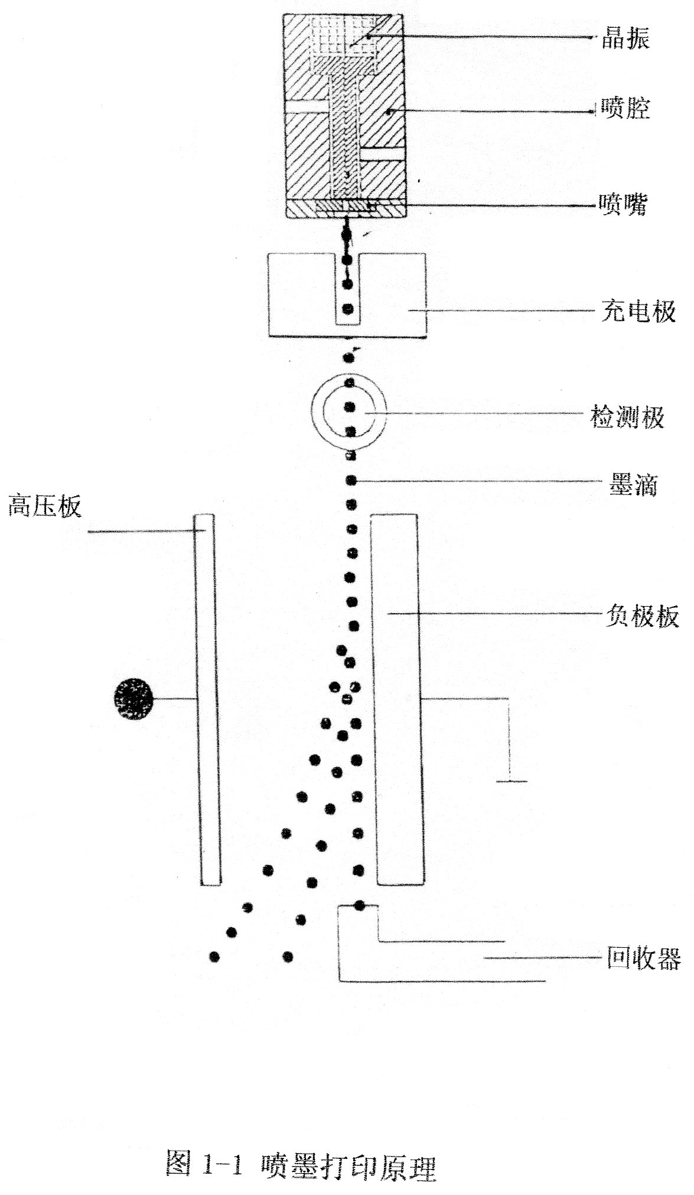
Recoverer
Negative plate
Ink droplet
Detection electrode
Charge electrode
Jet head
Jet cavity
Crystal oscillator
High voltage plate
Fig. 1-1: Theory of ink jetting and printing

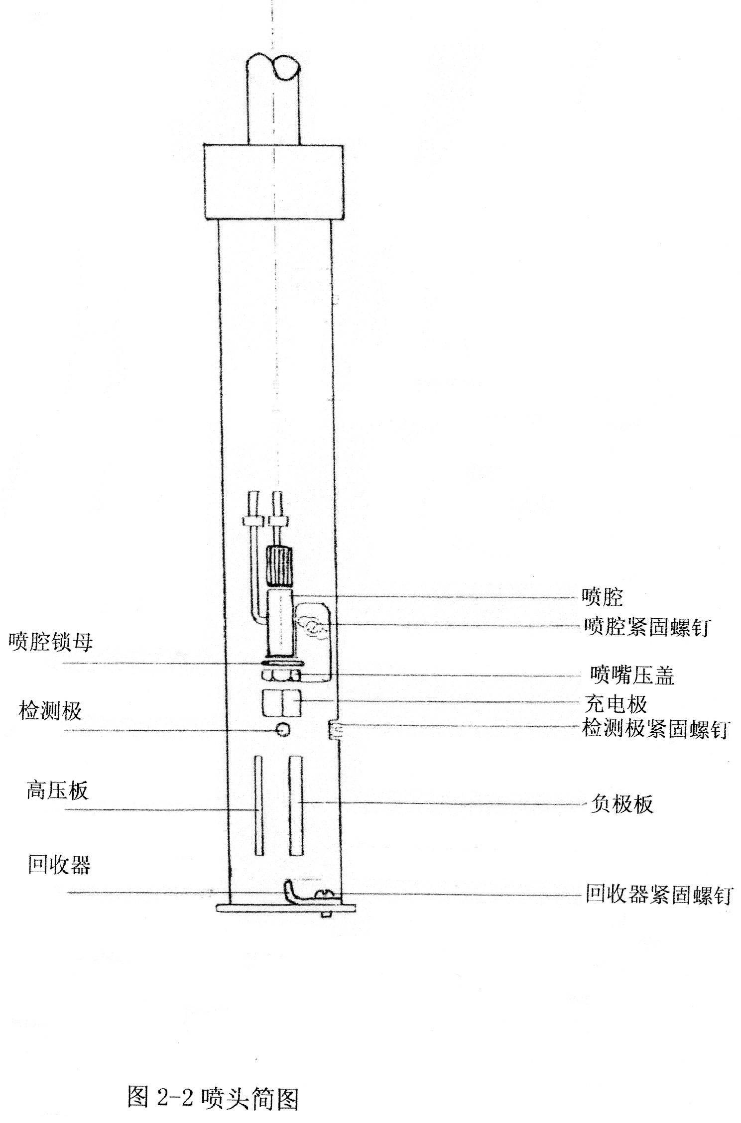
Fig.2-2: Sketch of jet head.
Fixing bolt of recoverer
Negative plate
Fixing bolt of detection electrode
Charge electrode
Capping of jet head
Jet cavity
Fixing bolt of jet cavity
Recoverer
High voltage plate
Detection electrode
Lock nut of jet cavity

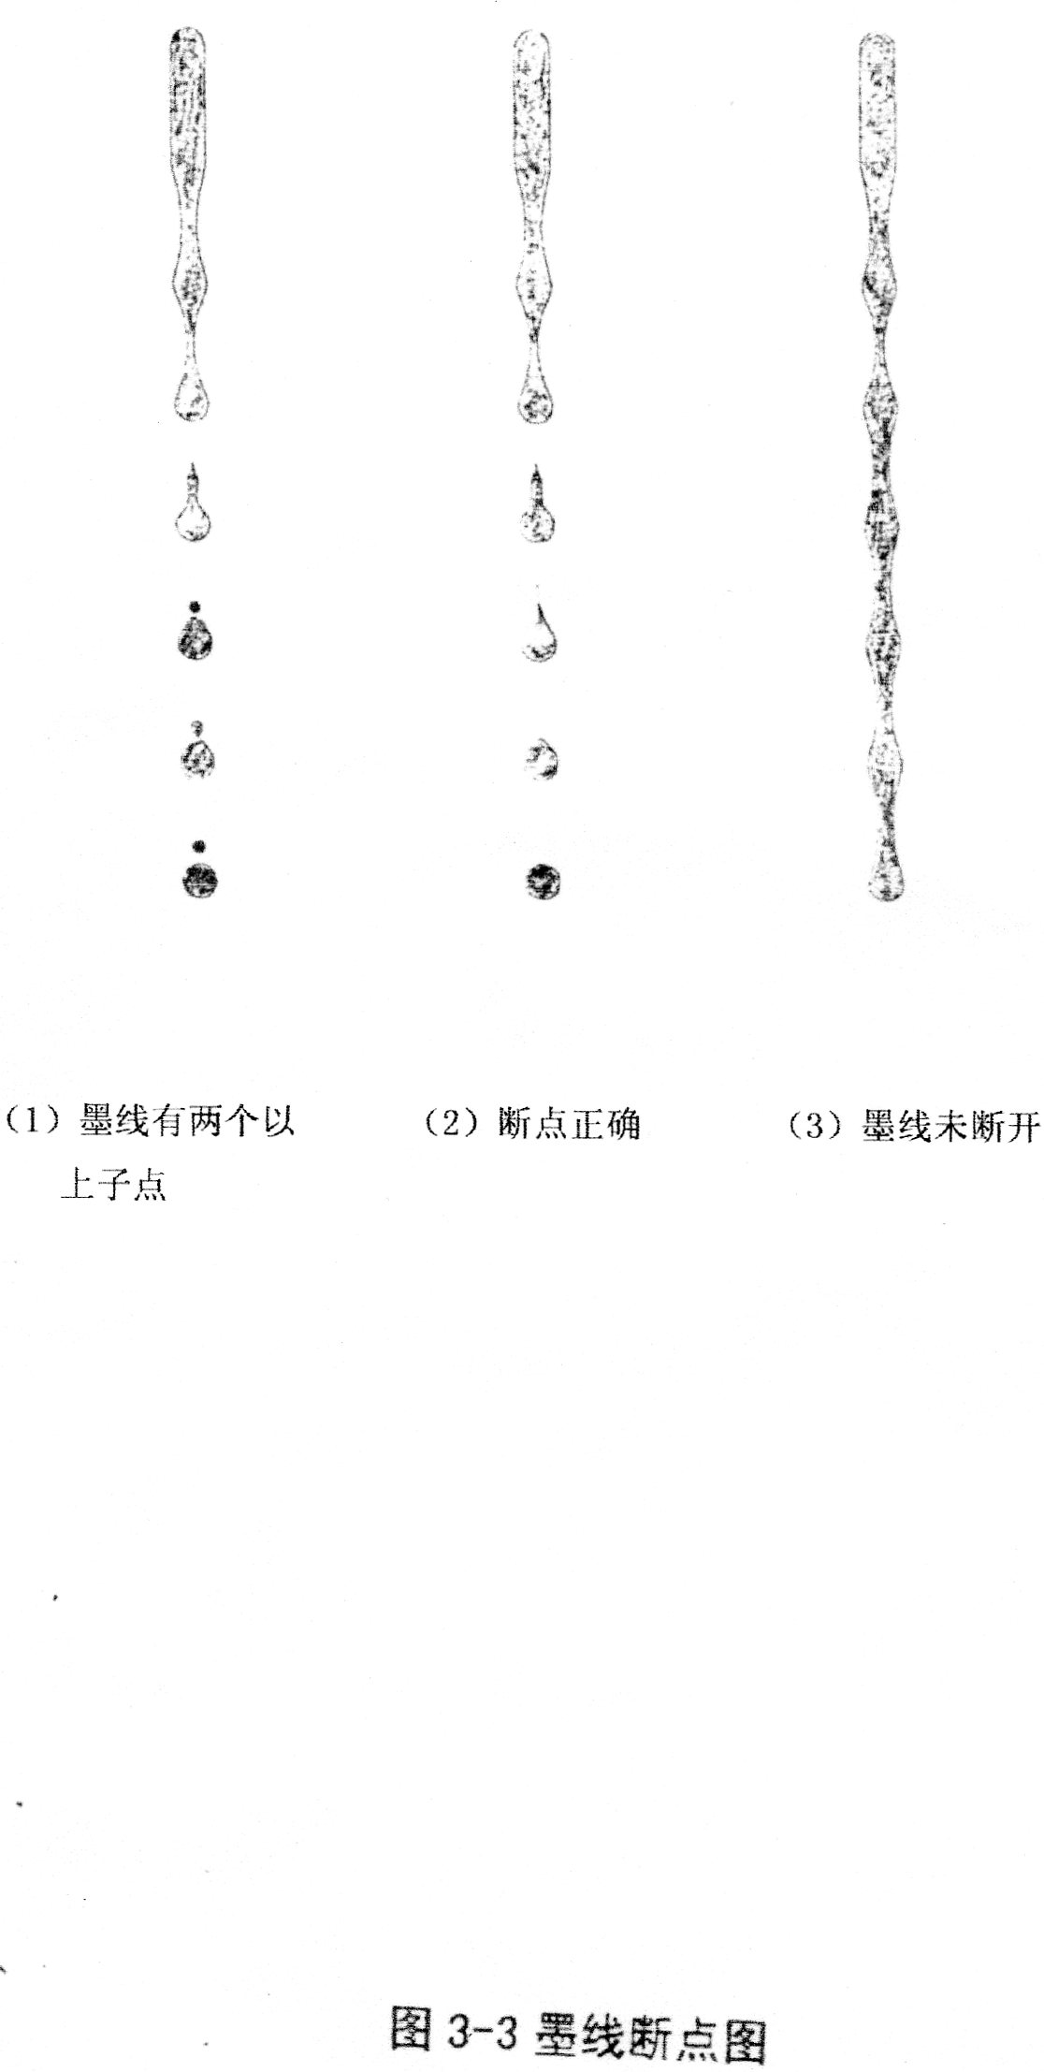
Fig. 3-3: Sketch of broken point of ink line
(1) There are at least two sub-points in the ink line
(2) The broken point is proper
(3) The ink line is not broken.

